Confidence Interval for the Sample Mean, Population Std Dev -- Known

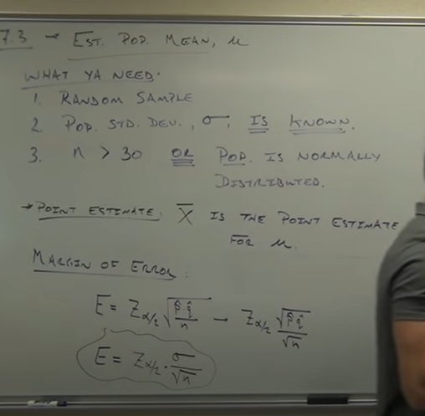

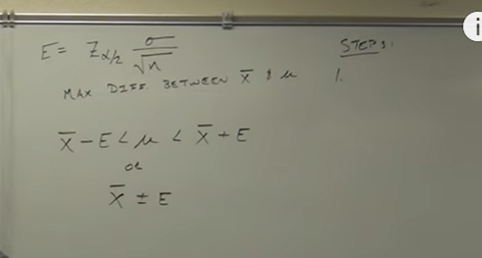

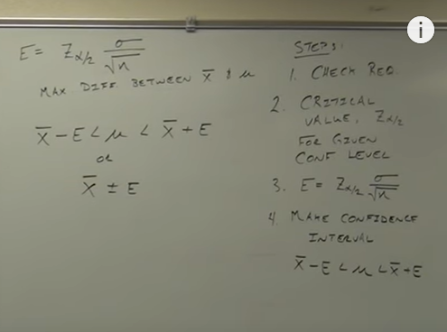

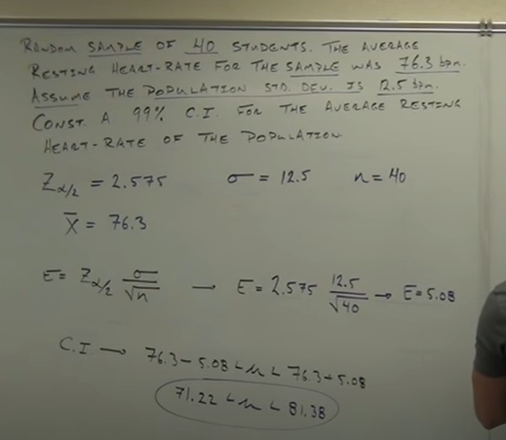

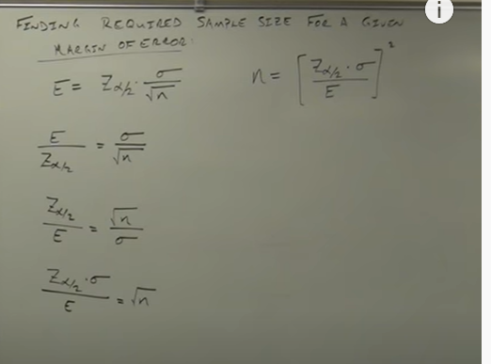

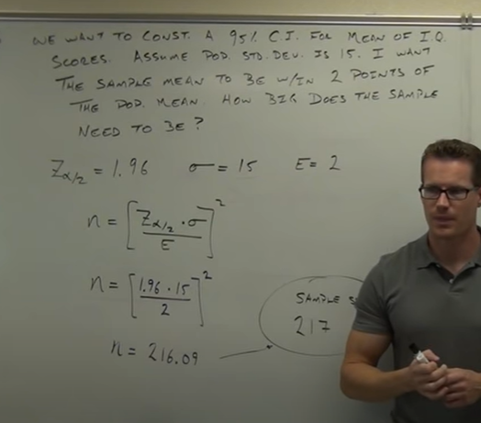

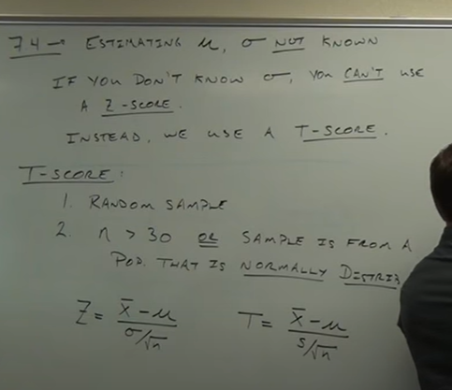

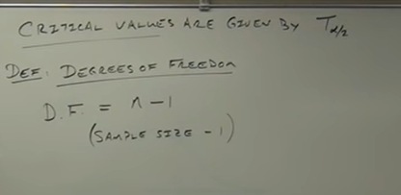

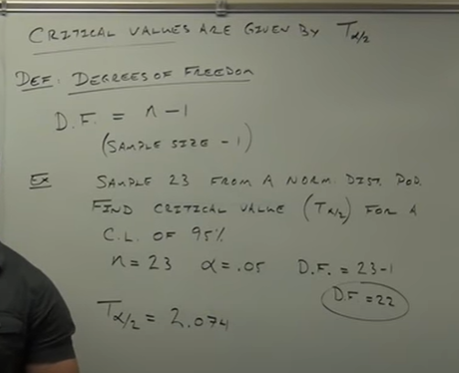

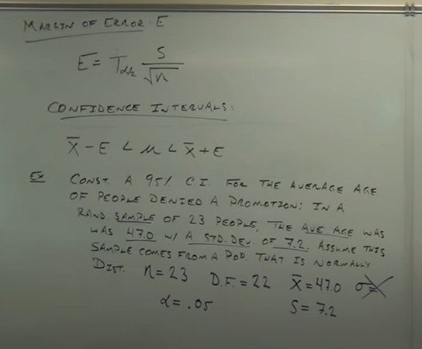

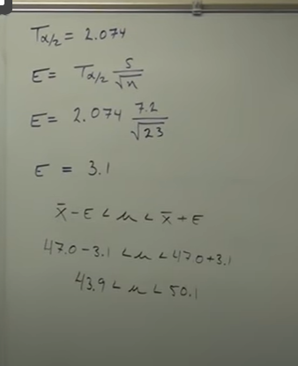

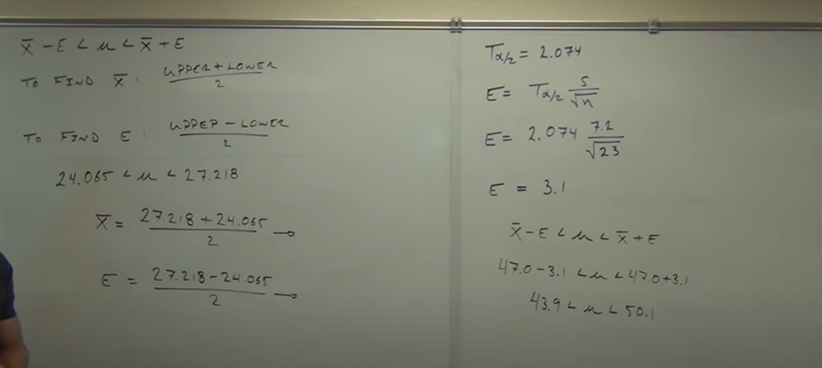

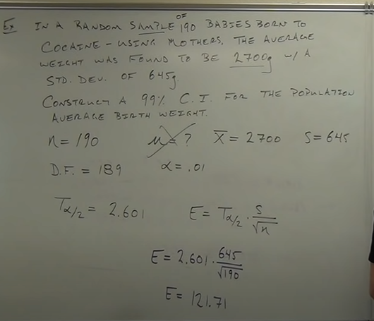

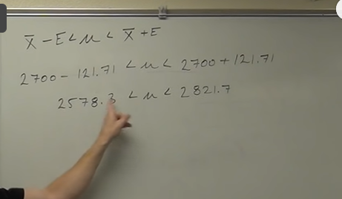

Confidence Intervals for Variance and Std Dev. Chi-Squared Distribution.

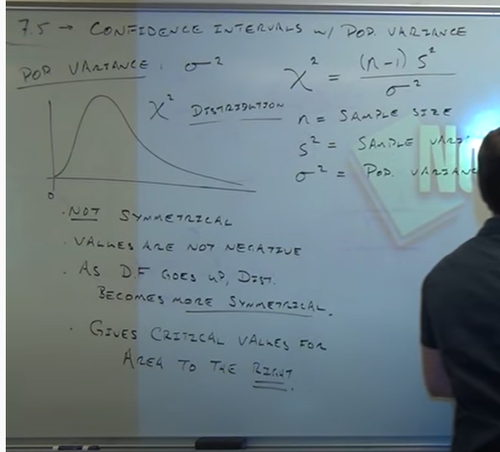

**Zero for chisquare is not middle**

**Its at leftside, so values are not negative**

**Variance will not be negative**

**Critical values are right**

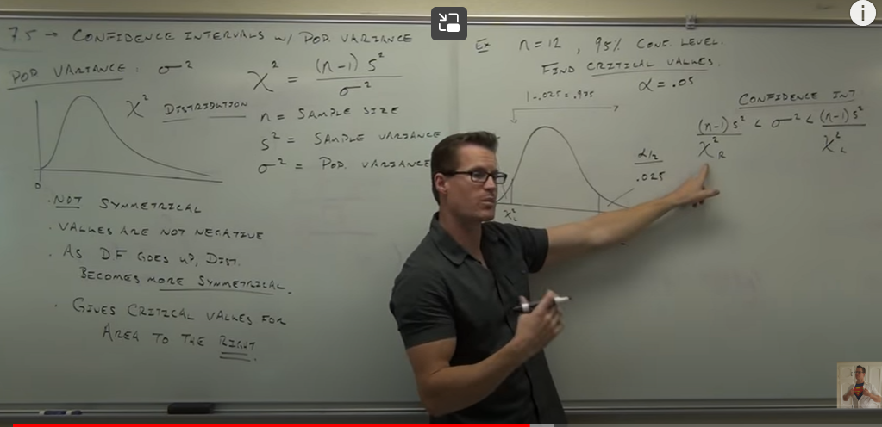

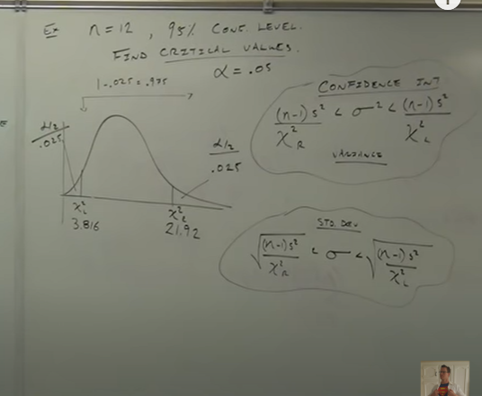

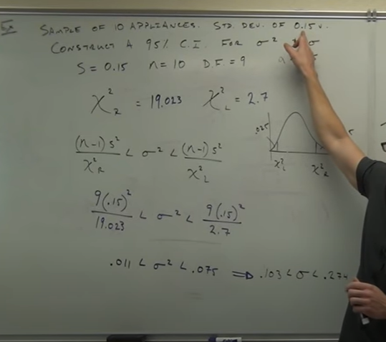

**Hypothesis: estimated educated test**

**Testing whether a claim is valid or not**

**What is claim?**

**Ex:**

**Most people get their jobs through networking**

**Most= proportions- more than 50 percent**

**Ex 2:**

**The avg payload of trucks on the 99 is 18000 lbs**

**Avg: mean**

**Meu= 18000**

**Translating claim into testing claim**

**We are making them into assumptions**

**Rare event rule: if the probability of assumption occurring is very small. The the assumption is probably incorrect**

**----Probability is not 100 percent sure---**

**Ex gender selection:**

**Claim: if u use this drug there will be at least 80 per chances of having a girl**

**A random sample of 100 couples studied**

**Assumption: 1.drug doesn’t work(means 50 percent girl and 50 per boy)**

**1)52/100 had girls- not rare event**

**2)97/100 had girls- rare event**

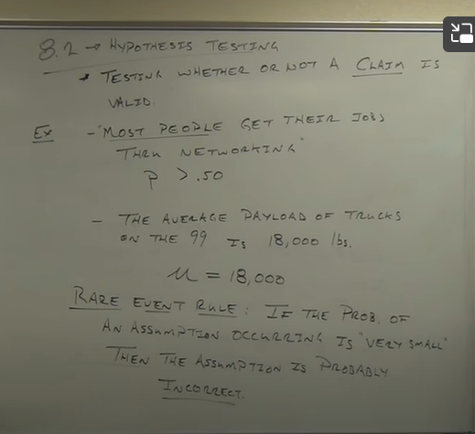



**Null Hypothesis vs alternative hypothesis(parts of hyp test)**

**Null hyp:**

**Alternative hyp:**

**Null Hyp: statement of equality (population parameters( proportion(P) or mean or sd equals to some values)**

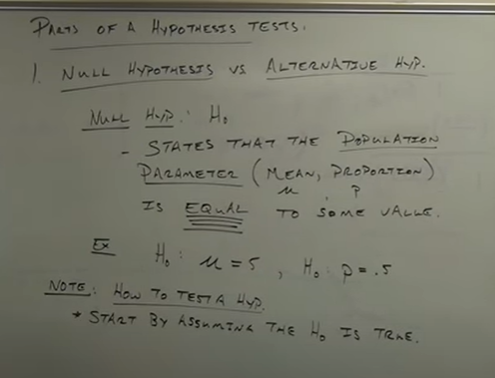

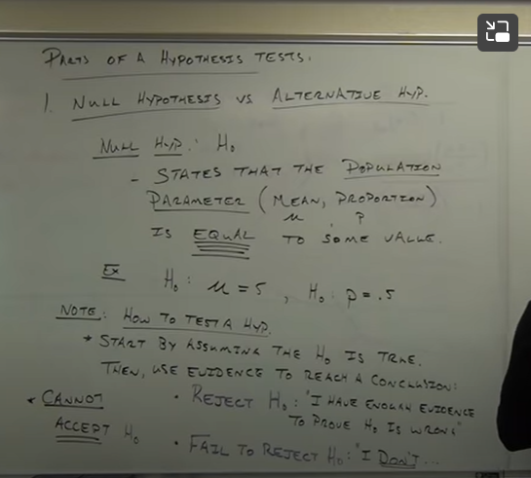

**Reject null hyp means accepting alternative**

**Fail to reject null hyp means – neither accepting null nor alternative**

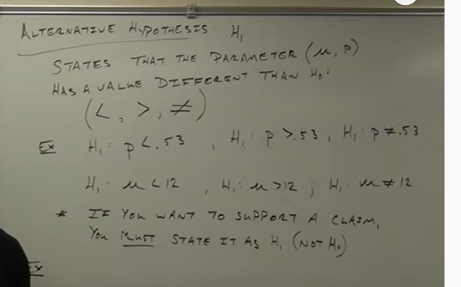

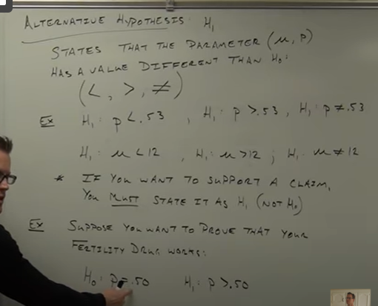

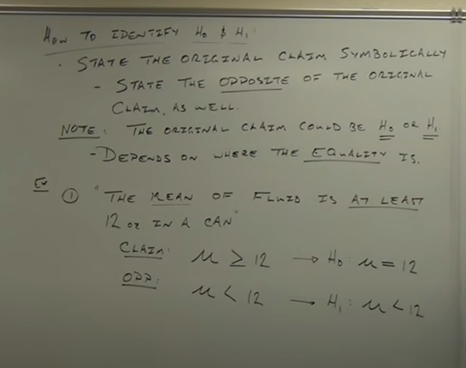

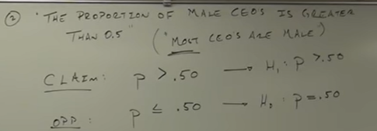

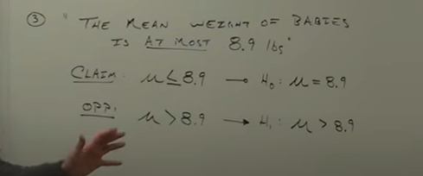

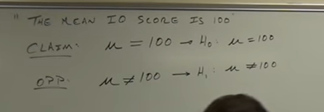

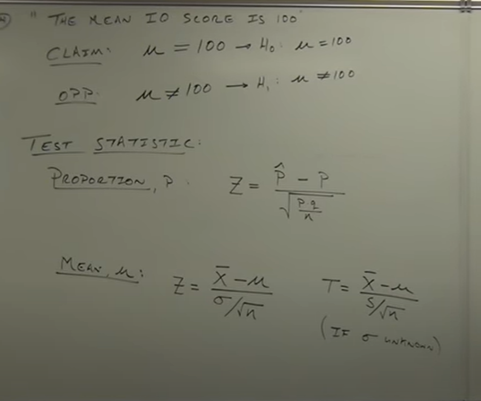

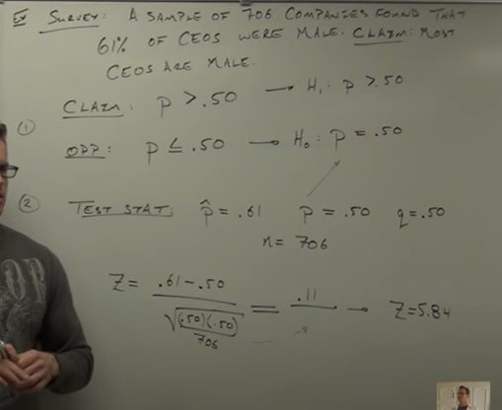

**Now we have to know 5.8 is usual or unusual value**

**UNUSAL OR RARE**

**HO= WRONG**

**HI = RIGHT**

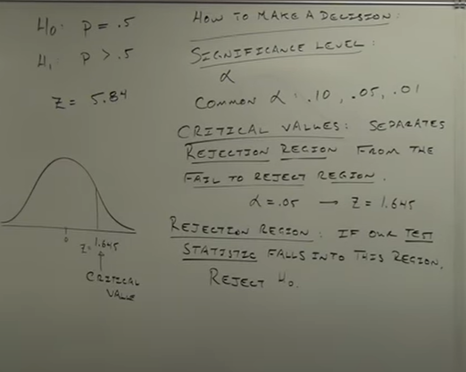

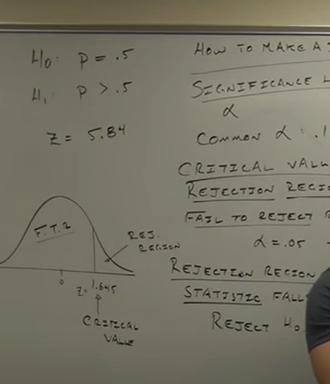

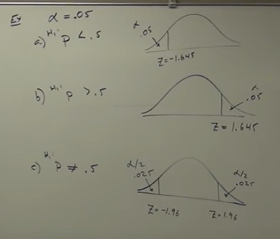

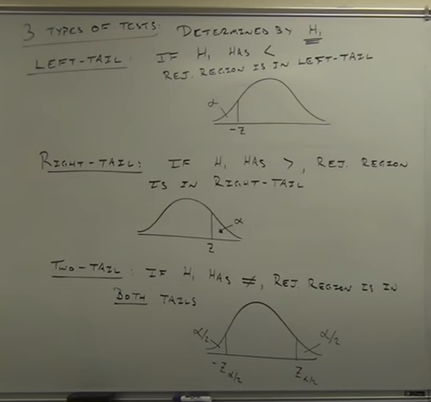

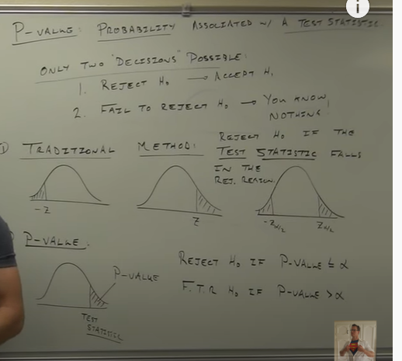

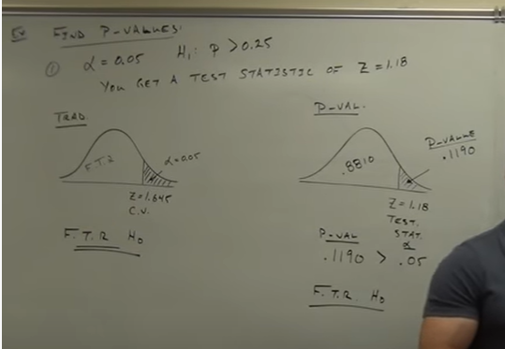

Table of Contents

* Fundamentals of Hypothesis Testing
  + Basic Concepts – Null Hypothesis, Alternative Hypothesis, Type 1 Error, Type 2 Error, and Significance Level
  + Steps to Perform Hypothesis Testing
  + Directional Hypothesis
  + Non Directional Hypothesis Test
* What is the Z Test?
  + One-Sample Z Test
  + Two Sample Z Test
* What is the t-Test?
  + One-Sample t-Test
  + Two-Sample t-Test
* Deciding between the Z Test and t-Test
* Case Study: Hypothesis Testing for Coronavirus in Python

Fundamentals of Hypothesis Testing



Let’s take an example to understand the concept of Hypothesis Testing. A person is on trial for a criminal offense and the judge needs to provide a verdict on his case. Now, there are four possible combinations in such a case:

* First Case: The person is innocent and the judge identifies the person as innocent
* Second Case: The person is innocent and the judge identifies the person as guilty
* Third Case: The person is guilty and the judge identifies the person as innocent
* Fourth Case: The person is guilty and the judge identifies the person as guilty

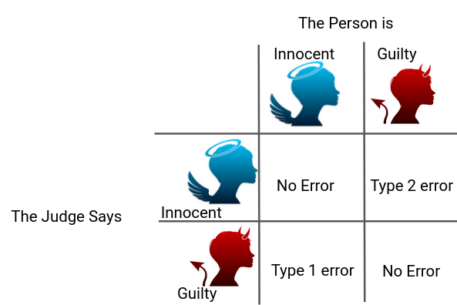

As you can clearly see, there can be two types of error in the judgment – Type 1 error, when the verdict is against the person while he was innocent and Type 2 error, when the verdict is in favor of Person while he was guilty

According to the Presumption of Innocence, the person is considered innocent until proven guilty. That means the judge must find the evidence which convinces him “beyond a reasonable doubt”. This phenomenon of **“Beyond a reasonable doubt”** can be understood as **Probability (Judge Decided Guilty | Person is Innocent) should be small.**

The basic concepts of Hypothesis Testing are actually quite analogous to this situation.

We consider**the Null Hypothesis** to be true until we find strong evidence against it. Then. we accept the **Alternate Hypothesis**. We also determine the **Significance Level (⍺**) which can be understood as the Probability of (Judge Decided Guilty | Person is Innocent) in the previous example. Thus, if ⍺ is smaller, it will require more evidence to reject the Null Hypothesis. Don’t worry, we’ll cover all of this using a case study later.

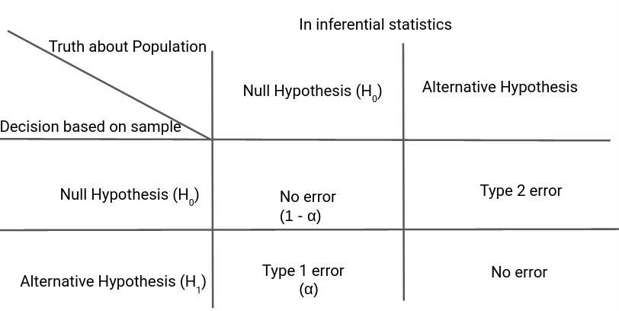

Steps to Perform Hypothesis testing

There are four steps to perform Hypothesis Testing:

* Set the Hypothesis
* Set the Significance Level, Criteria for a decision
* Compute the test statistics
* Make a decision

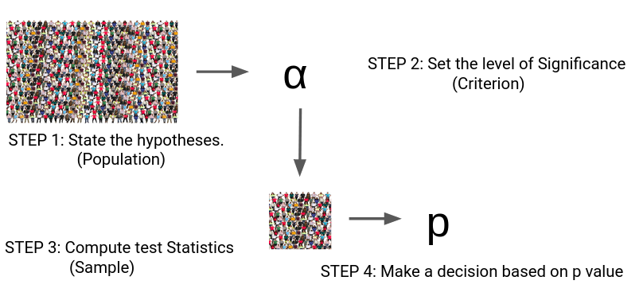  
Steps 1 to 3 are quite self-explanatory but on what basis can we make a decision in step 4? What does this[p-value](https://www.analyticsvidhya.com/blog/2019/09/everything-know-about-p-value-from-scratch-data-science/?utm_source=blog&utm_medium=statistics-analytics-hypothesis-testing-z-test-t-test) indicate?

We can understand this p-value as the measurement of the Defense Attorney’s argument. If the p-value is less than ⍺ , we reject the Null Hypothesis or if the p-value is greater than ⍺, we fail to reject the Null Hypothesis.

Critical Value, p-value

Let’s understand the logic of Hypothesis Testing with the graphical representation for [Normal Distribution](https://medium.com/analytics-vidhya/the-normal-distribution-for-data-scientists-6de041a01cb9).

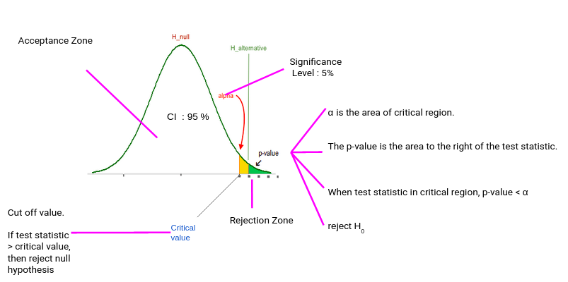

Typically, we set the Significance level at 10%, 5%, or 1%. If our test score lies in the Acceptance Zone we fail to reject the Null Hypothesis. If our test score lies in the critical zone, we reject the Null Hypothesis and accept the Alternate Hypothesis.

Critical Value is the cut off value between Acceptance Zone and Rejection Zone. We compare our test score to the critical value and if the test score is greater than the critical value, that means our test score lies in the Rejection Zone and we reject the Null Hypothesis. On the opposite side, if the test score is less than the Critical Value, that means the test score lies in the Acceptance Zone and we fail to reject the null Hypothesis.

*But why do we need p-value when we can reject/accept hypotheses based on test scores and critical value?*

p-value has the benefit that we **only need one value** to make a decision about the hypothesis. We don’t need to compute two different values like critical value and test scores. Another benefit of using p-value is that we can test at **any desired level of significance** by comparing this directly with the significance level.

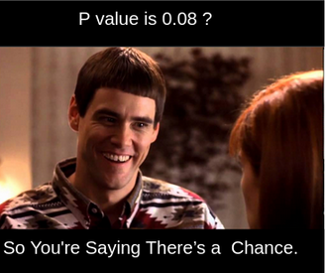

This way we don’t need to compute test scores and critical value for each significance level. We can get the p-value and directly compare it with the significance level.

Directional Hypothesis

In the Directional Hypothesis, the null hypothesis is rejected if the test score is too large (for right-tailed and too small for left tailed). Thus, the rejection region for such a test consists of one part, which is right from the center.

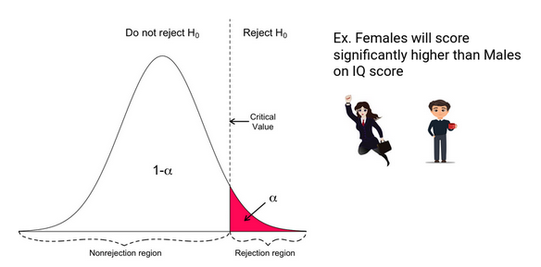

Non-Directional Hypothesis

In a Non-Directional Hypothesis test, the Null Hypothesis is rejected if the test score is either too small or too large. Thus, the rejection region for such a test consists of two parts: one on the left and one on the right.

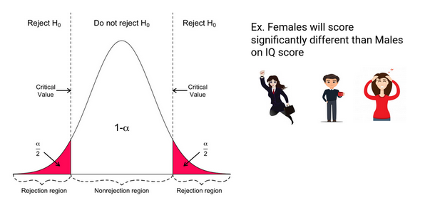

What is the Z Test?

z tests are a statistical way of testing a hypothesis when either:

* We know the population variance, or
* We do not know the population variance but our sample size is large n ≥ 30

*If we have a sample size of less than 30 and do not know the population variance, then we must use a t-test.*

One-Sample Z test

We perform the One-Sample Z test when we want to compare **a sample mean with the population mean.**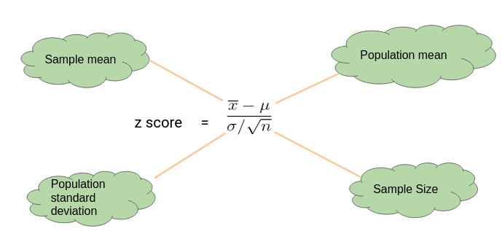

Here’s an Example to Understand a One Sample Z Test

Let’s say we need to determine **if girls on average score higher than 600 in the exam**. We have the information that the **standard deviation for girls’ scores is 100**. So, we collect the data of 20 girls by using random samples and record their marks. Finally, we also set **our ⍺ value (significance level) to be 0.05.**

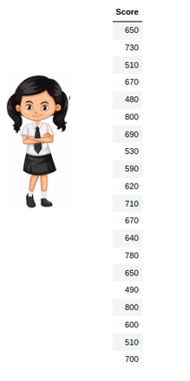

In this example:

* Mean Score for Girls is 641
* The size of the sample is 20
* The population mean is 600
* Standard Deviation for Population is 100

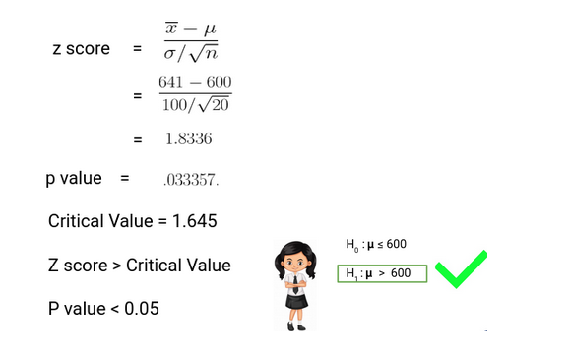

**Since the P-value is less than 0.05, we can reject the null hypothesis** and conclude based on our result that Girls on average scored higher than 600.

Two Sample Z Test

We perform a Two Sample Z test when we want to compare **the mean of two samples.**

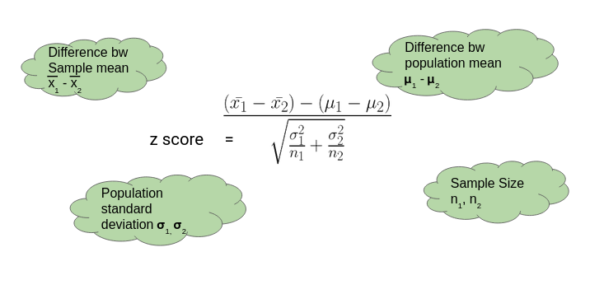

Here’s an Example to Understand a Two Sample Z Test

Here, let’s say we want to know if Girls on average score 10 marks more than the boys. We have the information that the standard deviation for girls’ Score is 100 and for boys’ score is 90. Then we collect the data of 20 girls and 20 boys by using random samples and record their marks. Finally, we also set our ⍺ value (significance level) to be 0.05.

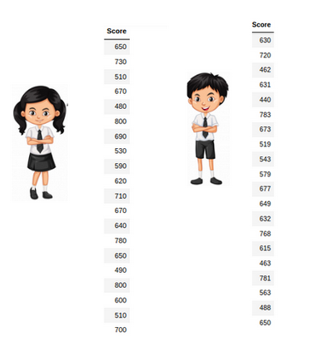

In this example:

* Mean Score for Girls (Sample Mean) is 641
* Mean Score for Boys (Sample Mean) is 613.3
* Standard Deviation for the Population of Girls’ is 100
* Standard deviation for the Population of Boys’ is 90
* Sample Size is 20 for both Girls and Boys
* Difference between Mean of Population is 10

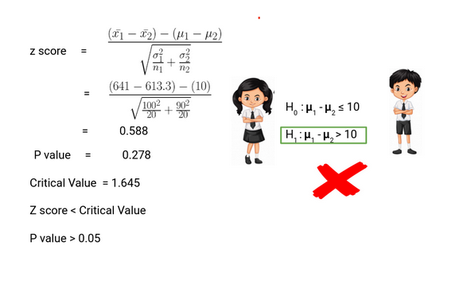

Thus, we can **conclude based on the P-value that we fail to reject the Null Hypothesi**s. We don’t have enough evidence to conclude that girls on average score of 10 marks more than the boys. Pretty simple, right?

What is the t-Test?

t-tests are a statistical way of testing a hypothesis when:

* We do not know the population variance
* Our sample size is small, n < 30

One-Sample t-Test

We perform a One-Sample t-test when we want to **compare a sample mean with the population mean**. The difference from the Z Test is that we do **not have the information on Population Variance** here. We use the **sample standard deviation** instead of population standard deviation in this case.

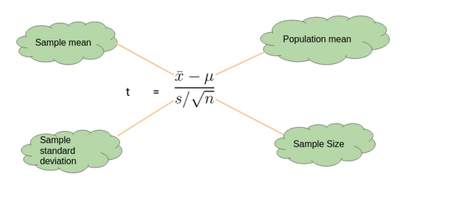

Here’s an Example to Understand a One Sample t-Test

Let’s say we want to determine if on average girls score more than 600 in the exam. We do not have the information related to variance (or standard deviation) for girls’ scores. To a perform t-test, we randomly collect the data of 10 girls with their marks and choose our ⍺ value (significance level) to be 0.05 for Hypothesis Testing.

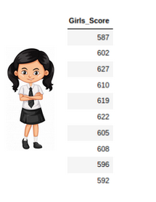

In this example:

* Mean Score for Girls is 606.8
* The size of the sample is 10
* The population mean is 600
* Standard Deviation for the sample is 13.14

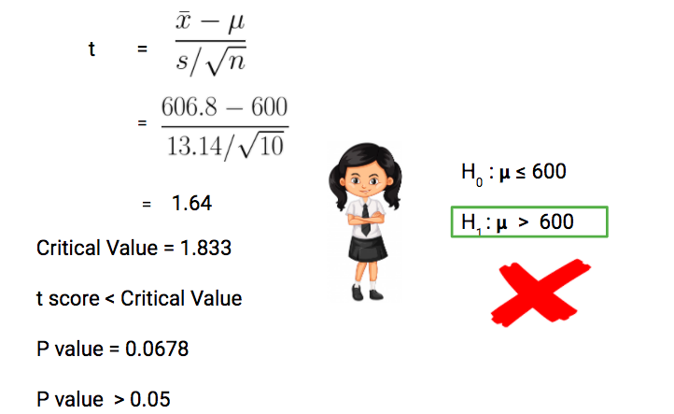

Our**P-value is greater than 0.05 thus we fail to reject the null hypothesis** and don’t have enough evidence to support the hypothesis that on average, girls score more than 600 in the exam.

Two-Sample t-Test

We perform a Two-Sample t-test when we want to compare the mean of two samples.

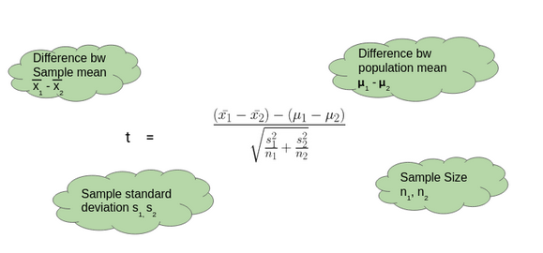

Here’s an Example to Understand a Two-Sample t-Test

Here, let’s say we want to determine if on average, boys score 15 marks more than girls in the exam. We do not have the information related to variance (or standard deviation) for girls’ scores or boys’ scores. To perform a t-test. we randomly collect the data of 10 girls and boys with their marks. We choose our ⍺ value (significance level) to be 0.05 as the criteria for Hypothesis Testing.

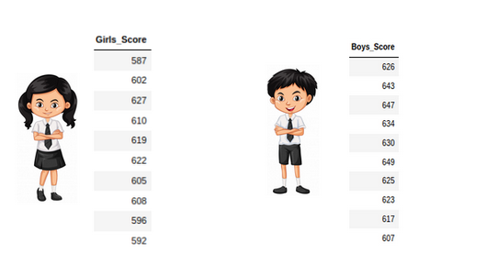

In this example:

* Mean Score for Boys is 630.1
* Mean Score for Girls is 606.8
* Difference between Population Mean 15
* Standard Deviation for Boys’ score is 13.42
* Standard Deviation for Girls’ score is 13.14

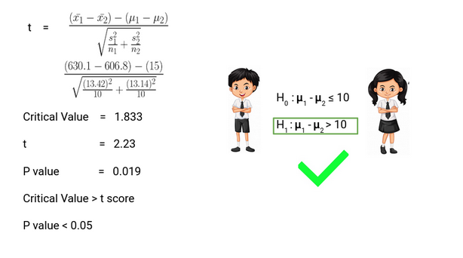

Thus, **P-value is less than 0.05 so we can reject the null hypothesis** and conclude that on average boys score 15 marks more than girls in the exam.

Deciding between Z Test and T-Test

So when we should perform the Z test and when we should perform t-Test? It’s a key question we need to answer if we want to master statistics.

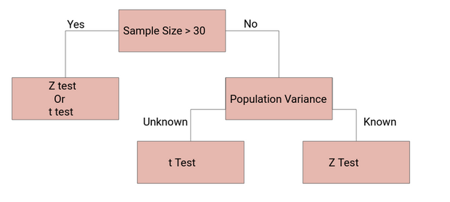

If the sample size is large enough, then the Z test and t-Test will conclude with the same results. For a**large sample size**, **Sample Variance will be a better estimate** of Population variance so even if population variance is unknown, we can**use the Z test using sample variance.**

Similarly, for a**Large Sample**, we have a high degree of freedom. And since t**-distribution approaches the normal distribution**,**t**he difference between the z score and t score is negligible.

Case Study: Hypothesis Testing for Coronavirus using Python

Now let’s implement the Two-Sample Z test for a coronavirus dataset. Let’s put our theoretical knowledge into practice and see how well we can do. You can download the dataset [here.](https://drive.google.com/file/d/1IJija1WXjC6gDtVAczyTsvSOmLe3iu6Y/view?usp=sharing)

This dataset has been taken from **John Hopkin’s repository** and you can find the link [here](https://github.com/CSSEGISandData/COVID-19/tree/master/csse_covid_19_data/csse_covid_19_daily_reports) for it.

This dataset here the below features:

* Province/State
* Country/Region
* Last Update
* Confirmed
* Deaths
* Recovered
* Lattitude
* Longitude

And we have added the feature of **Temperature and Humidity** for Latitude and Longitude using Python’s Weather API – *Pyweatherbit*. A common perception about COVID-19 is that Warm Climate is more resistant to the corona outbreak and we need to verify this using Hypothesis Testing. So what will our null and alternate hypothesis be?

* Null Hypothesis: Temperature doesn’t affect COV-19 Outbreak
* Alternate Hypothesis: Temperature does affect COV-19 Outbreak

*Note: We are considering Temperature below 24 as Cold Climate and above 24 as Hot Climate in our dataset.*

import pandas as pd

import numpy as np

corona = pd.read\_csv('Corona\_Updated.csv')

corona['Temp\_Cat'] = corona['Temprature'].apply(lambda x : 0 if x < 24 else 1)

corona\_t = corona[['Confirmed', 'Temp\_Cat']]

def TwoSampZ(X1, X2, sigma1, sigma2, N1, N2):

from numpy import sqrt, abs, round

from scipy.stats import norm

ovr\_sigma = sqrt(sigma1\*\*2/N1 + sigma2\*\*2/N2)

z = (X1 - X2)/ovr\_sigma

pval = 2\*(1 - norm.cdf(abs(z)))

return z, pval

d1 = corona\_t[(corona\_t['Temp\_Cat']==1)]['Confirmed']

d2 = corona\_t[(corona\_t['Temp\_Cat']==0)]['Confirmed']

m1, m2 = d1.mean(), d2.mean()

sd1, sd2 = d1.std(), d2.std()

n1, n2 = d1.shape[0], d2.shape[0]

z, p = TwoSampZ(m1, m2, sd1, sd2, n1, n2)

z\_score = np.round(z,8)

p\_val = np.round(p,6)

if (p\_val<0.05):

Hypothesis\_Status = 'Reject Null Hypothesis : Significant'

else:

Hypothesis\_Status = 'Do not reject Null Hypothesis : Not Significant'

print (p\_val)

print (Hypothesis\_Status)

0.180286

Do not reject Null Hypothesis : Not Significant

Thus. we do not have evidence to reject our Null Hypothesis that temperature doesn’t affect the COV-19 outbreak. Although we cannot find the Temperature’s impact on COV-19, this problem has just been taken for the conceptual understanding of what we have learned in this article. There are certain limitations of the Z test for COVID-19 datasets:

* Sample data may not be well representative of population data
* Sample variance may not be a good estimator of the population variance
* Variability in a state’s capacity to deal with this pandemic
* Socio-Economic Reasons
* Early breakout in certain places
* Some states could be hiding the data for geopolitical reasons

So, we need to be more cautious and research more to identify the pattern of this pandemic.

End Notes

In this article, we followed a step by step procedure to understand the fundamentals of Hypothesis Testing, Type 1 Error, Type 2 Error, Significance Level, Critical Value, p-Value, Non-Directional Hypothesis, Directional Hypothesis, Z Test and t-Test and finally implemented Two Sample Z Test for a coronavirus case study.

For more details you can also read these articles:

* [Your Guide to Master Hypothesis Testing in Statistics](https://www.analyticsvidhya.com/blog/2015/09/hypothesis-testing-explained/?utm_source=blog&utm_medium=statistics-analytics-hypothesis-testing-z-test-t-test)
* [Statistics for Data Science: Introduction to t-test and its Different Types (with Implementation in R)](https://www.analyticsvidhya.com/blog/2019/05/statistics-t-test-introduction-r-implementation/?utm_source=blog&utm_medium=statistics-analytics-hypothesis-testing-z-test-t-test)

Always remember – “Statistics is the Grammar of Data Science”. Did you find this article useful? Can you think of any other applications of different statistical tests? Let me know in the comments section below and we can come up with more ideas.

**Related**

**What is requirement.txt file in Python?** In Python requirement.txt file is a**type of file that usually stores information about all the libraries, modules, and packages in itself that are used while developing a particular project**. It also stores all files and packages on which that project is dependent or requires to run.

You can approach this by dividing your dataframe df according to whether you want to **forward** **fill** or **backward** **fill** those rows: create two copies of your df, one with everything forward filled and the other with everything back filled fill\_forward = df.status.fillna (method='ffill') fill\_backward = df.status.fillna (method='bfill')

**Bernoulli distribution and Bernoulli trials explained**

Bernoulli distribution applies to events that have **one trial** and **two possible outcomes**.

These are known as Bernoulli trials. Think of any kind of experiment that asks a yes or no question—for example, will this coin land on heads when I flip it? Will I roll a six with this die? Will I pick an ace from this deck of cards? Will voter X vote “yes” in a political referendum? Will student Y pass their math test?

You get the idea. In Bernoulli trials, the two possible outcomes can be thought of in terms of “success” or “failure”—but these labels are not to be taken literally. In this context, “success” simply means getting a “yes” outcome (for example, rolling a six, picking an ace, and so on).

The Bernoulli distribution is, essentially, a calculation that allows you to create a model for the set of possible outcomes of a Bernoulli trial. So, whenever you have an event that has only two possible outcomes, Bernoulli distribution enables you to calculate the probability of each outcome.

**What’s the difference between Bernoulli distribution and binomial distribution?**

While grappling with Bernoulli distribution, you’ve likely come across another term: binomial distribution. So what’s the difference between the two, and how do they relate to one another?

In very simplistic terms, a Bernoulli distribution is a type of binomial distribution. We know that Bernoulli distribution applies to events that have one trial (n = 1) and two possible outcomes—for example, one coin flip (that’s the trial) and an outcome of either heads or tails. When we have more than one trial—say, we flip a coin five times—binomial distribution gives the discrete probability distribution of the number of “successes” in that sequence of independent coin flips (or trials).

So, to continue with the coin flip example: Bernoulli distribution gives you the probability of “success” (say, landing on heads) when flipping the coin just once (that’s your Bernoulli trial). If you flip the coin five times, binomial distribution will calculate the probability of success (landing on heads) across all five coin flips.

That’s a very simplistic overview—you’ll find a more detailed [**explanation of binomial distribution here**](https://en.wikipedia.org/wiki/Binomial_distribution). For now, let’s return to Bernoulli distribution with some examples.

**3. Examples of Bernoulli distribution**

**Bernoulli distribution example: Tossing a coin**

The coin toss example is perhaps the easiest way to explain Bernoulli distribution. Let’s say that the outcome of “heads” is a “success,” while an outcome of “tails” is a “failure.” In this instance:

* The probability of a successful outcome (landing on heads) is written as ***p***
* The probability of a failure (landing on tails), written as ***q***, is calculated  as ***1 \*\*****–*\*\* ***p***

With a standard coin, we know that there’s a 50/50 chance of landing on either heads or tails. So, in this case:

* *p = 0.5*
* *q = 1****– \*\*****0.5*

So, in our coin toss example, both *p* and *q = 0.5*. On a graph, you’d represent the probability of a failure as “0” and the probability of success as “1,” both on the y-axis.

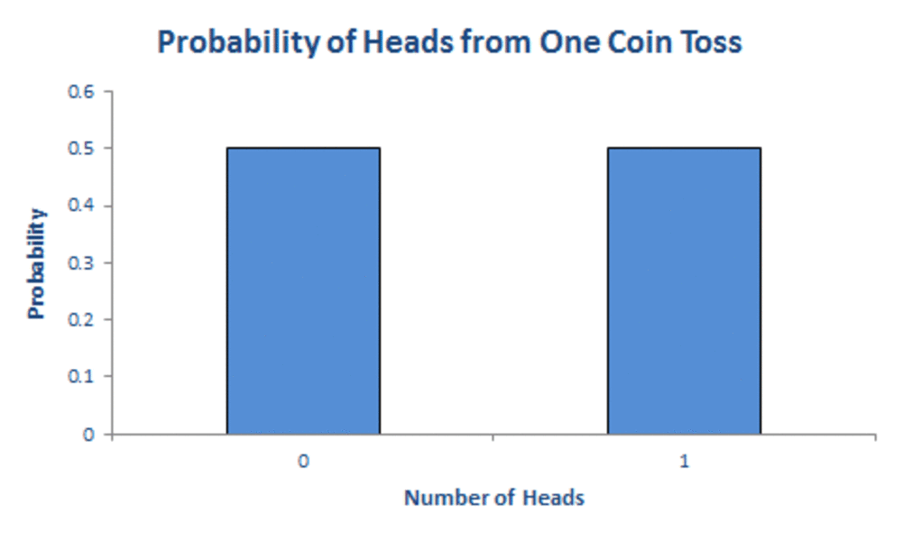

**Further examples of Bernoulli distribution**

The coin-toss example is a very simple one, but there are actually many scenarios in life that have a yes-no outcome. For example:

* Will you pass or fail a test?
* Will your favorite sports team win or lose their next match?
* Will you be accepted or rejected for that job you applied for?
* Will you roll a six in the opening round of your favorite board game?
* Will you win or lose the lottery?

In this article, Swizec Teller explains how [**Bernoulli trials and Bernoulli distribution can help you figure out how many job applications you need to send out before you get a job**](https://swizec.com/blog/bernoullis-trials-can-tell-you-how-many-job-applications-to-send). Bernoulli distribution is also used in medicine and clinical trials to model the success rate of a certain drug or the outcome of a clinical trial. For example, when developing a new drug, pharmaceutical scientists can use Bernoulli distribution to calculate the probability that a person will be cured or not cured with the help of the new drug. Bernoulli distributions are also used in logistic regression to model the occurrence of disease. You can [**learn more about logistic regression in this post**](https://careerfoundry.com/en/blog/data-analytics/what-is-logistic-regression/).

**4. What are the conditions for Bernoulli distribution?**

To help you understand when and how Bernoulli distribution applies, it’s useful to consider the conditions for Bernoulli trials. An event or experiment can only be considered a Bernoulli trial (and thus be relevant for Bernoulli distribution) if it meets these criteria:

* **There are only two possible outcomes from the trial.** Another way to think of this is in terms of “success” or “failure”—in other words, does your experiment ask a “yes or no” question? Think back to our previous examples, such as “Will student X pass their math test?” or “Will patient Y be cured when they take this drug?”
* **Each of the two outcomes has a fixed probability of occurring.** In other words, no matter how many times you flip a coin, the probability of landing on heads is fixed. In mathematical terms, the probability of success is always *p*, and the probability of failure is always *1* – *p.*
* **Trials are entirely independent of each other.** The result of one trial (say, the first coin flip) has absolutely no bearing on the outcome of any subsequent coin flips.

If a scenario meets all three of those criteria, it can be considered a Bernoulli trial. Now we’re familiar with Bernoulli distribution, let’s consider where it comes into play in the broader fields of data analytics, data science, and machine learning.

**5. Bernoulli distribution in data analytics, data science, and machine learning**

Probability distributions, such as Bernoulli distribution, are not only useful for mathematicians and statisticians; they also have a crucial role to play in data analytics, data science, and machine learning. Data analysts and data scientists work with large volumes of data, and looking at the distribution of a given dataset is an essential part of [**exploratory data analysis**](https://careerfoundry.com/en/blog/data-analytics/exploratory-data-analysis/)—that is, getting an initial understanding of your data before you investigate further.

In machine learning, many models work based on distribution assumptions, and the Bernoulli distribution (and other discrete probability distributions) are primarily used in the modeling of binary and multi-class classification problems. Some examples of binary classification models include spam filters which detect whether an email should be classified as “spam” or “not spam,” models that can predict whether a customer will take a certain action or not, or classifying a product as, say, a book or a film. An example of a multi-class classification model could be a model that identifies which category of products will be most relevant to a particular customer.

As one of the more simple distributions, Bernoulli distribution often serves as a starting point for more complex distributions. For example, the Bernoulli process lays the foundation for binomial distribution, geometric distribution, and negative binomial distribution—all of which play a crucial role in deep learning. You can [**learn more about deep learning (and how it differs from machine learning) in this guide**](https://careerfoundry.com/en/blog/data-analytics/machine-learning-vs-deep-learning/).

So, if you’re keen to delve deeper into data analytics, data science, or machine learning, probability distributions, like the Bernoulli distribution, are a good place to start.

**6. Key takeaways and further reading**

In this post, we introduced Bernoulli distribution—a concept worth getting to grips with if you’re considering a career in any kind of data-related field. To recap:

* Bernoulli distribution is a discrete probability distribution
* It describes the probability of achieving a “success” or “failure” from a Bernoulli trial
* A Bernoulli trial is an event that has only two possible outcomes (success or failure). For example, will a coin land on heads (success) or tails (failure)?
* Bernoulli distribution is a type of binomial distribution

**PMF, PDF and CDF in Machine Learning**

Random variables and the various distribution functions which form the foundations of Machine Learning

**Table of contents**

* Introduction
* Random Variable and its types
* PDF (probability density function)
* PMF (Probability Mass function)
* CDF (Cumulative distribution function)
* Example
* Further Reading

**Introduction**

**PDF**and **CDF**are commonly used techniques in the Exploratory data analysis to finding the probabilistic relation between the variables.

Before going through the contents in this page ,first go through the fundamental concepts like **random variable**, **pmf**, **pdf and cdf.**

**Random variable**

A random variable is a variable whose value is unknown to the function i.e, the value is depends upon the outcome of experiment

For example, while throwing a dice, the variable value is depends upon the outcome.

Mostly random variables are used for regression analysis to determine statistical relationship between each other. There are 2 types of random variable:

***1 — Continuous random variable***

***2 — Discrete random variable***

***Continuous random variable:-***A variable which having the values between the range/interval and take infinite number of possible ways is called Continuous random variable . OR the variables whose values are obtained by measuring is called Continuous random variable. For e.g, A average height of 100 peoples, measurement of rainfall

***Discrete Random Variable:-***A variable which takes countable number of distinct values. OR the variables whose values are obtained by counting is called Discrete Random Variable. For e.g, number of students present in class

**PDF (Probability Density Function):-**

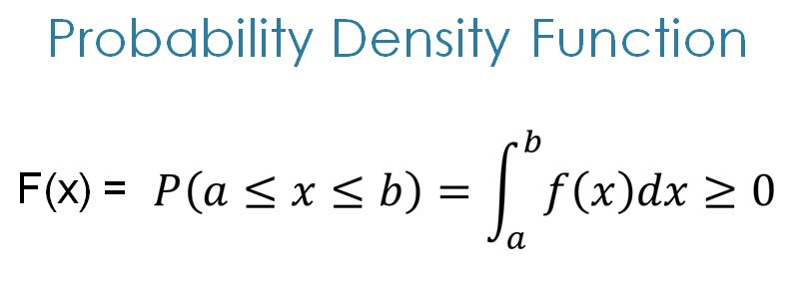

**The formula for PDF**

*PDF is a statistical term that describes the probability distribution of the****continues****random variable*

PDF most commonly follows the Gaussian Distribution. If the features / random variables are Gaussian distributed then PDF also follows Gaussian Distribution. On PDF graph the probability of single outcome is always zero, this happened because the single point represents the line which doesn’t cover the area under the curve.

**PMF (Probability Mass Function):-**

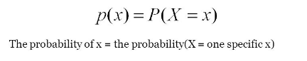

Fig:- Formula for PMF

*PMF is a statistical term that describes the probability distribution of the****Discrete****random variable*

People often get confused between PDF and PMF. The PDF is applicable for continues random variable while PMF is applicable for discrete random variable For e.g, Throwing a dice (You can only select 1 to 6 numbers (countable) )

**CDF (Cumulative Distribution Function):-**

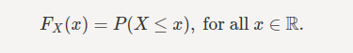

Fig:- Formula for CDF

PMF is a way to describe distribution but its only applicable for discrete random variables and not for continuous random variables. The **cumulative distribution function** is applicable for describing the distribution of random variables either it is continuous or discrete

**For example**, if X is the height of a person selected at random then F(x) is the chance that the person will be shorter than x. If F(180 cm)=0.8. then there is an 80% chance that a person selected at random will be shorter than 180 cm (equivalently, a 20% chance that they will be taller than 180cm)

**Python example for PDF and CDF on Iris Dataset:-**

The [*iris data set*](https://www.kaggle.com/uciml/iris) contains the following data:-

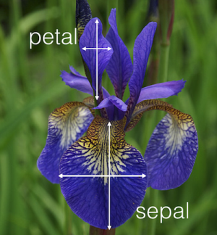

Fig:- Flower image from iris dataset

The detailed explanation of iris data-set is [here](https://www.ritchieng.com/machine-learning-iris-dataset/)

**PDF On Iris:-**

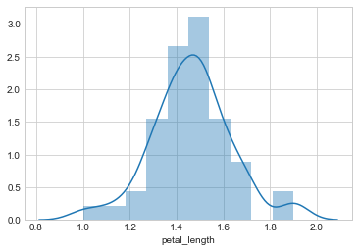

PDF for [‘species’]== ‘setosa’ on petal length

**CDF on Iris:-**

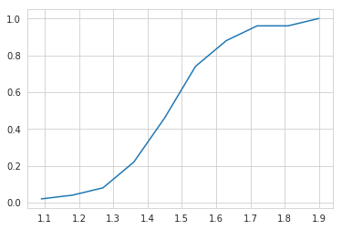

CDf of iris\_setosa using petal length

**Both PDF and CDF visualisation:-**

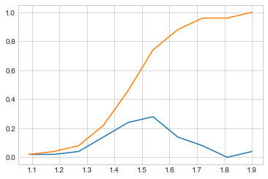

Pdf and Cdf

*You will find the detailed explanation with python code on****[Github](https://github.com/MurliJadhav/Pdf-Cdf/blob/master/EDA_Plotting_iris.ipynb" \t "_blank)***[*Here*](https://github.com/MurliJadhav/Pdf-Cdf/blob/master/EDA_Plotting_iris.ipynb)*.*

Probability distribution plays a vital role in the statistics and today we can see about the probability mass function, probability density function and the cumulative distribution function in simple english {Especially for people, allergic towards mathematical expressions 😅}

**Random Variable :**

A random or stochastic variable is the result of a chance event, that you may measure or count. It is a variable that assumes numerical values associated with the random outcomes of an experiment where one (and only one) numerical value is assigned to each sample point. Let us consider the example of flipping a coin once, wherein the possible outcome is either a head or tail denoted by 1 and 0 respectively. Another example is the random possible outcome while rolling a dice which is one among the following (1,2,3,4,5,6).The random variable is of two types viz.,

1. Discrete Random Variable
2. Continuous Random Variable

**Discrete Random Variable :**

A discrete random variable is variable which takes the numerical outcome of the chance event or any countable number of possible values. An example is the number of people visiting the hospital in a day. It can never be a decimal value.

**Continuous Random Variable :**

A random variable is said to be a continuous random variable if it takes infinite number of values in an interval. The probability of the random variable taking any one specific value is zero.The random variable "X" can take any possible values in an interval of real numbers. For example X ∈ [0,1].

**What is Probability Distribution & Why?**

Probability Distribution is a function which lists all the possible outcomes a random variable can take, along with its corresponding probability of occurrence. Although the random variable has the ability to assume a random value it lacks the capability to capture the probability of occurrence those value. The probability distribution can also be plotted as a graph.

**Probability Mass Function :**

The probability distribution of a Discrete Random Variable is called as Probability Mass Function or PMF. The probability mass function, f(x) = P(X = x), of a discrete random variable X has the following properties:

1. All probabilities are positive : P(x) ≥ 0.
2. Any event in the distribution has a probability of happening of between 0 and 1. 0 ≤ P(x) ≤ 1. (e.g. 0% and 100%).
3. The sum of all probabilities is 1. So ∑P(x) = 1.

**Probability Density Function :**

The probability density function is the statistical function that defines the probability distribution of a continuous random variable. When the probability density function is graphically plotted, the area under the curve will indicate the interval in which the variable will fall. The total area in this interval of the graph equals the probability of a discrete random variable occurring. The sum of all probabilities should be equal to 1. It is impossible to find the probability of a particular continuous random variable since the summation of probability of all random variables within an interval will be infinite.

**Cumulative Distributive Function :**

The cumulative distribution function is is applicable for both discrete and continuous random variable.The cumulative distribution function gives the cumulative value from negative infinity up to a random variable X and is defined by the following notation:

F(x) = P(X≤x)

I hope this article helped you with random variables, probability distributions and the differences between pmf, pdf, cdf. Probability distributions help in modelling and predicting different outcomes of various events in real life.

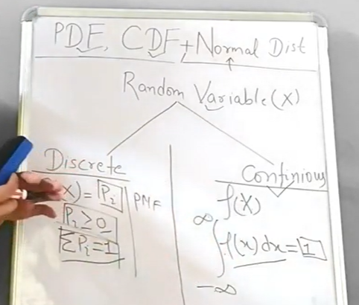

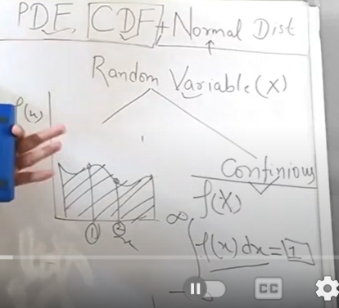

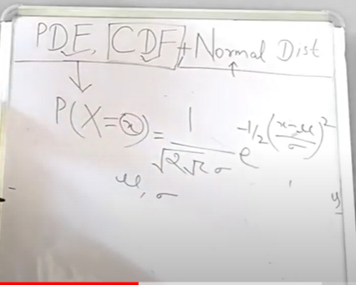

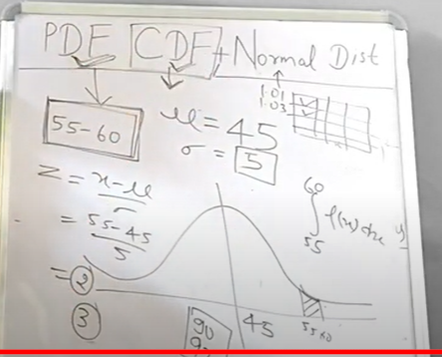

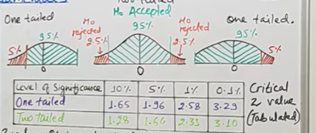

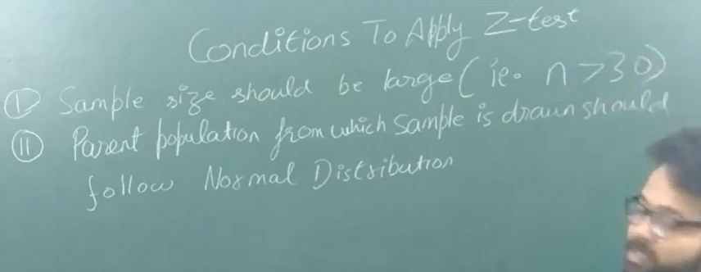



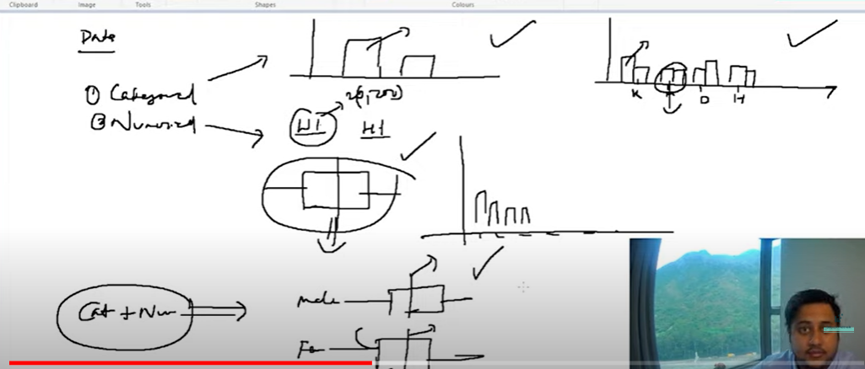

**Dual numerical : scatter**

**Dual categorical**

**Correlation: two numerical**

**Categorial: one sample proportion**

**Categorical+ numerical: t test**

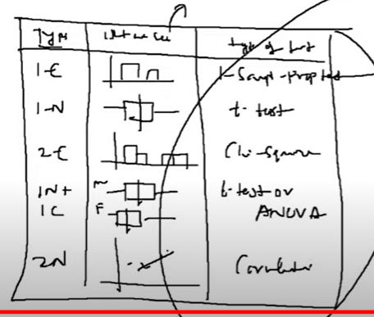

**Z Test:**

**Compare means of two sample wether they are from same distribution**

**Sample size greater than 30**

**One sample test: test if sample mean is different from kown or hypothesized population**

**Two samples : compare two independent variables**

**One categorical plus one numerical (income of male and female)**

**Correlation test: -1 to +1**

**Anova: analysis of variance**

Variance as parameter to compare independent groups

One way or two da

One way: two or 3 independent groups

F=MST/MSE

One categorical and one nuemerical

Income of male and female equal

**CHISQUARE:**

Twocategorical

If there is relation between two categorical

Gender and loan status

Two features to analyze; degree of freedom is 1

SCIPY(stats library)

Null hyp: no significance difference between variables or features

Analyzing one variable: distribution of female and male is no difference

HYPOTESIS testing

[Hypothesis Testing | T Test, Z Test and Chi Square | Types of Hypothesis Testing | Satyajit Pattnaik - YouTube](https://www.youtube.com/watch?v=uJan469HPp4)

**Level of significance**: how much error can be allowed

Not sure about your null hypothesis

**Confidence level**: interval estimated. Has upper and lower limits

**Test statistics**: to take decision wether to accept null hypothesis will be based on test statistics.

Z and T test

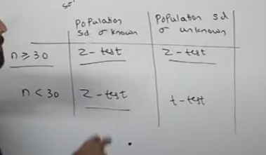

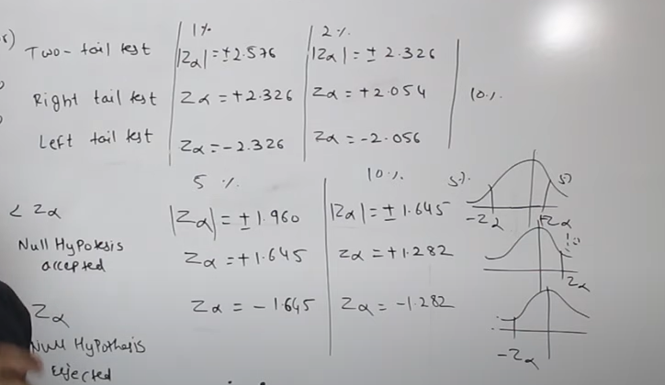

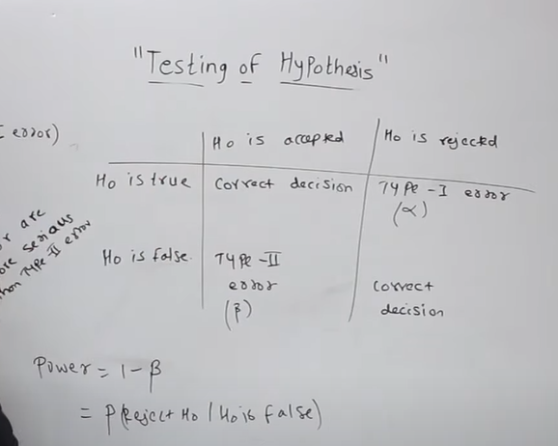

Type 1 error more serious than type 2 error

**Power of test :**

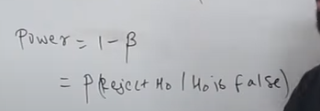

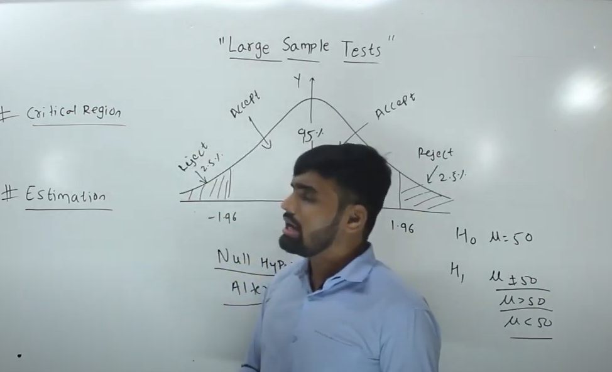

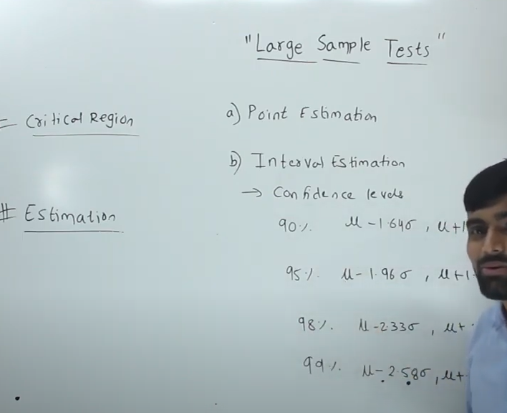

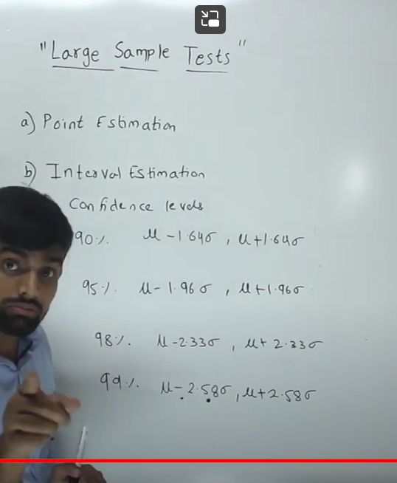

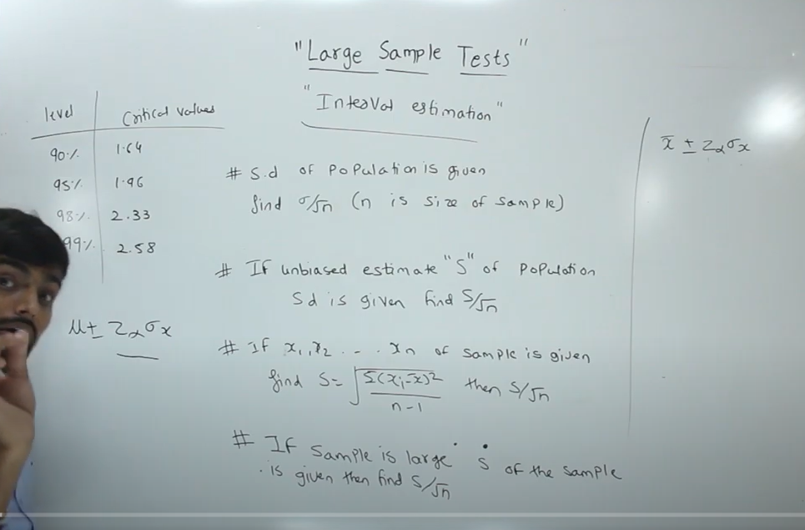

**Chisquare test:**

**Non parametric**

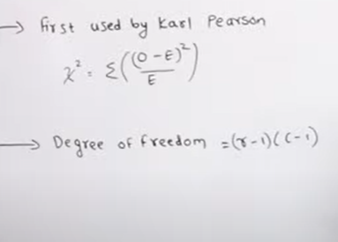

**O: observed frequency**

**E= expected frequency**

**Two attributes :**

**1. educated father and uneducated father(2 attributes)**

**2. son educated and non-educated**

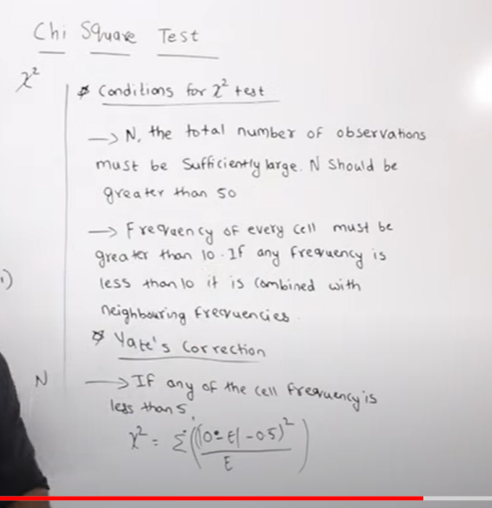

**F Test**

F test is a statistical test that is used in hypothesis testing to check whether the variances of two populations or two samples are equal or not

. In an f test, the data follows an f distribution. This test uses the f statistic to compare two variances by dividing them. An f test can either be one-tailed or two-tailed depending upon the parameters of the problem.

The f value obtained after conducting an f test is used to perform the one-way ANOVA (analysis of variance) test. In this article, we will learn more about an f test, the f statistic, its critical value, formula and how to conduct an f test for hypothesis testing.

**What is F Test in Statistics?**

F test is statistics is a test that is performed on an f distribution. A two-tailed f test is used to check whether the [variances](https://www.cuemath.com/data/variance/) of the two given samples (or populations) are equal or not. However, if an f test checks whether one population variance is either greater than or lesser than the other, it becomes a one-tailed hypothesis f test.

**F Test Definition**

F test can be defined as a test that uses the f test statistic to check whether the variances of two samples (or populations) are equal to the same value. To conduct an f test, the population should follow an f distribution and the samples must be independent events. On conducting the hypothesis test, if the results of the f test are statistically significant then the null hypothesis can be rejected otherwise it cannot be rejected.

**F Test Formula**

The f test is used to check the equality of variances using [hypothesis testing](https://www.cuemath.com/data/hypothesis-testing/). The f test formula for different hypothesis tests is given as follows:

**Left Tailed Test:**

Null Hypothesis: H0H0 : σ21=σ22σ12=σ22

Alternate Hypothesis: H1H1 : σ21<σ22σ12<σ22

Decision Criteria: If the f statistic < f critical value then reject the null hypothesis

**Right Tailed test:**

Null Hypothesis: H0H0 : σ21=σ22σ12=σ22

Alternate Hypothesis: H1H1 : σ21>σ22σ12>σ22

Decision Criteria: If the f test statistic > f test critical value then reject the null hypothesis

**Two Tailed test:**

Null Hypothesis: H0H0 : σ21=σ22σ12=σ22

Alternate Hypothesis: H1H1 : σ21≠σ22σ12≠σ22

Decision Criteria: If the f test statistic > f test critical value then the null hypothesis is rejected

**F Statistic**

The f test statistic or simply the f statistic is a value that is compared with the critical value to check if the null hypothesis should be rejected or not. The f test statistic formula is given below:

F statistic for large samples: F = σ21σ22σ12σ22, where σ21σ12 is the variance of the first population and σ22σ22 is the variance of the second population.

F statistic for small samples: F = s21s22s12s22, where s21s12 is the variance of the first sample and s22s22 is the variance of the second sample.

The selection criteria for the σ21σ12 and σ22σ22 for an f statistic is given below:

* For a right-tailed and a two-tailed f test, the variance with the greater value will be in the numerator. Thus, the sample corresponding to σ21σ12 will become the first sample. The smaller value variance will be the denominator and belongs to the second sample.
* For a left-tailed test, the smallest variance becomes the numerator (sample 1) and the highest variance goes in the denominator (sample 2).

**F Test Critical Value**

A [critical value](https://www.cuemath.com/data/critical-value/) is a point that a test statistic is compared to in order to decide whether to reject or not to reject the null hypothesis. Graphically, the critical value divides a distribution into the acceptance and rejection regions. If the test statistic falls in the rejection region then the null hypothesis can be rejected otherwise it cannot be rejected. The steps to find the f test critical value at a specific alpha level (or significance level), αα, are as follows:

* Find the degrees of freedom of the first sample. This is done by subtracting 1 from the first sample size. Thus, x = n1−1n1−1.
* Determine the degrees of freedom of the second sample by subtracting 1 from the sample size. This given y = n2−1n2−1.
* If it is a right-tailed test then αα is the significance level. For a left-tailed test 1 - αα is the alpha level. However, if it is a two-tailed test then the significance level is given by αα / 2.
* The F table is used to find the critical value at the required alpha level.
* The intersection of the x column and the y row in the f table will give the f test critical value.

**ANOVA F Test**

The one-way [ANOVA](https://www.cuemath.com/anova-formula/) is an example of an f test. ANOVA stands for analysis of variance. It is used to check the variability of group means and the associated variability in observations within that group. The F test statistic is used to conduct the ANOVA test. The hypothesis is given as follows:

H0H0: The means of all groups are equal.

H1H1: The means of all groups are not equal.

Test Statistic: F = explained variance / unexplained variance

Decision rule: If F > F critical value then reject the null hypothesis.

To determine the critical value of an ANOVA f test the degrees of freedom are given by df1df1 = K - 1 and df1df1 = N - K, where N is the overall sample size and K is the number of groups.

**F Test vs T-Test**

F test and t-test are different types of statistical tests used for hypothesis testing depending on the distribution followed by the population data. The table given below outlines the differences between the F test and the t-test.

| **F Test** | **T-Test** |
| --- | --- |
| An F test is a test statistic used to check the equality of variances of two populations | The [T-test](https://www.cuemath.com/t-test-formula/) is used when the sample size is small (n < 30) and the population standard deviation is not known. |
| The data follows an F distribution | The data follows a Student t-distribution |
| The F test statistic is given as F = σ21σ22σ12σ22 | The t-test statistic for 1 sample is given by t = ¯¯¯x−μs√nx¯−μsn, where ¯¯¯xx¯ is the sample mean, μμ is the population mean, s is the sample standard deviation and n is the sample size. |
| The f test is used for variances. | It is used for testing [means](https://www.cuemath.com/data/mean/). |

**Related Articles:**

* [Probability and Statistics](https://www.cuemath.com/data/statistics/)
* [Data Handling](https://www.cuemath.com/data/data-handling/)
* [Summary Statistics](https://www.cuemath.com/data/summary-statistics/)

**Important Notes on F Test**

* The f test is a statistical test that is conducted on an F distribution in order to check the equality of variances of two populations.
* The f test formula for the test statistic is given by F = σ21σ22σ12σ22.
* The f critical value is a cut-off value that is used to check whether the null hypothesis can be rejected or not.
* A one-way ANOVA is an example of an f test that is used to check the variability of group means and the associated variability in the group observations.

Chisquare test:

Binomial distribution

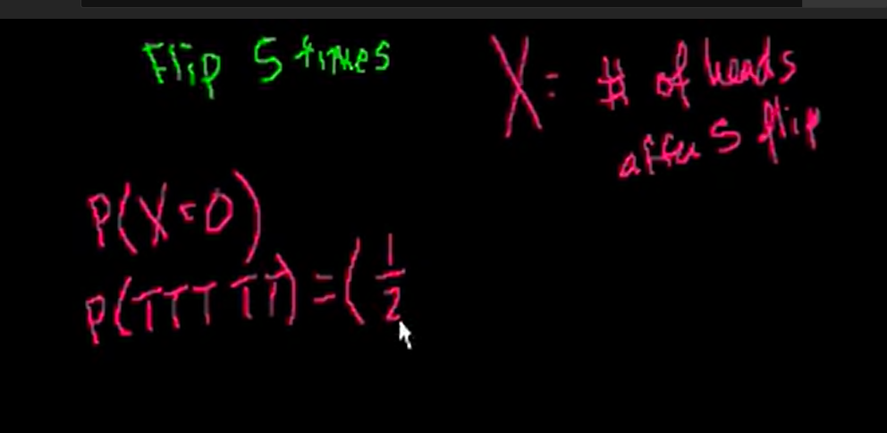

X = number of heads for 5 flips

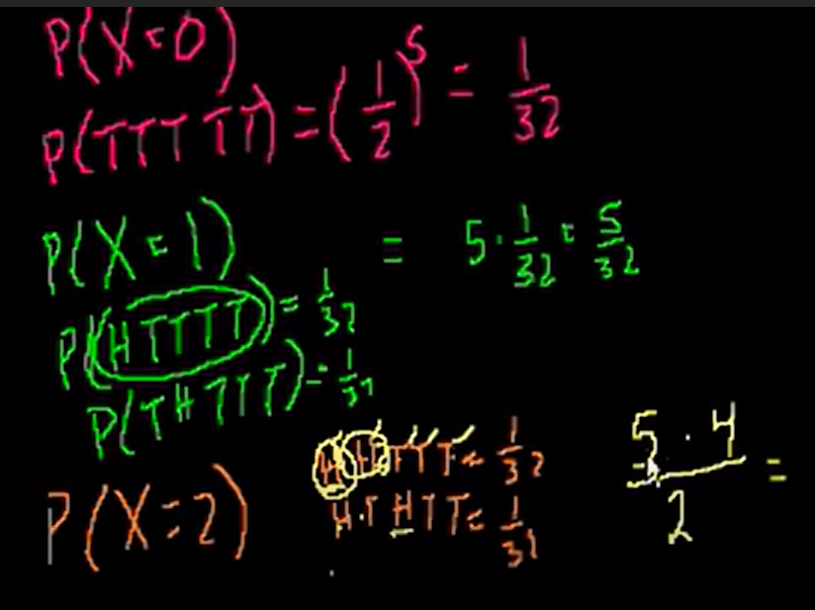

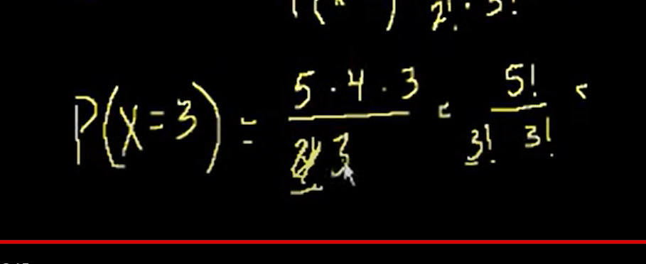

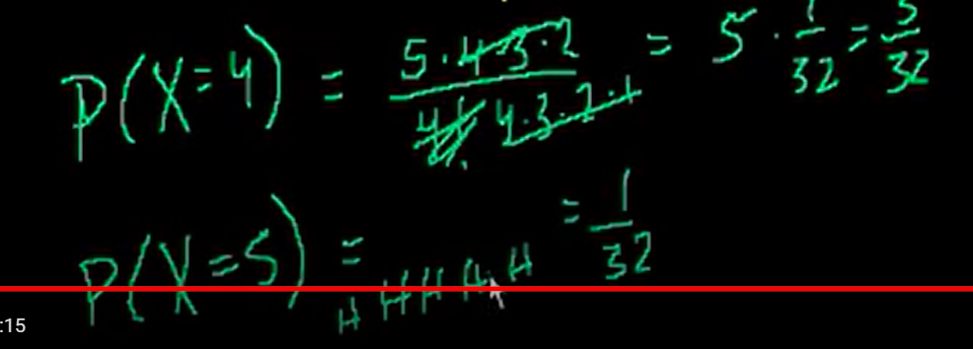

Probability of 1 head, no head, 2 heads ……

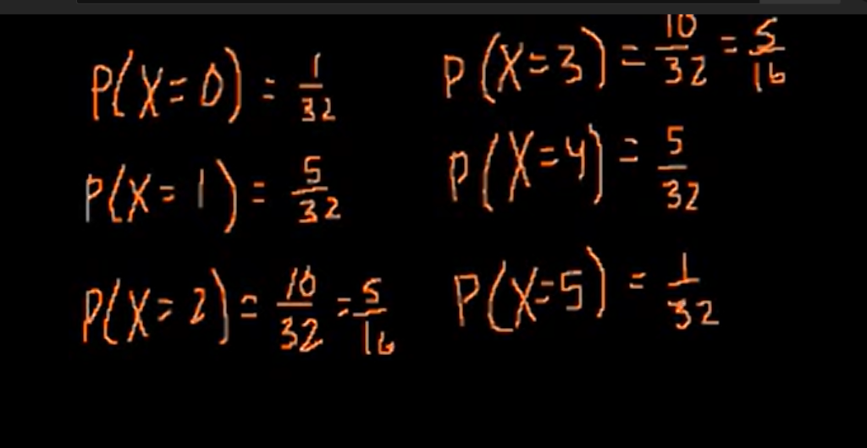

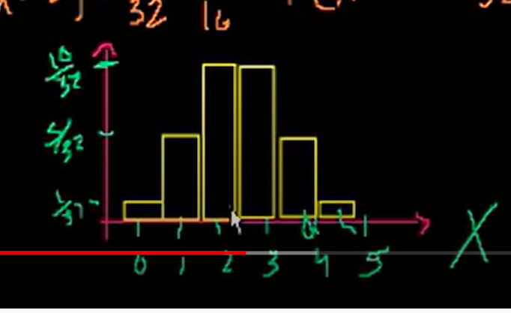

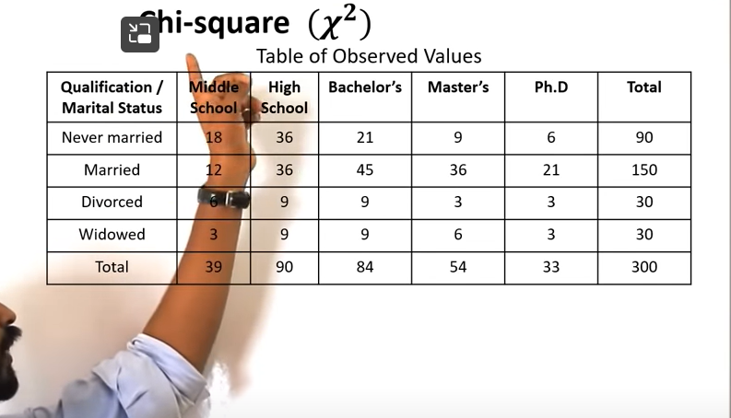

**Two variables: educational and marital related with each other**

**Null: no correlation**

**Alternative : significance relation**

**‘**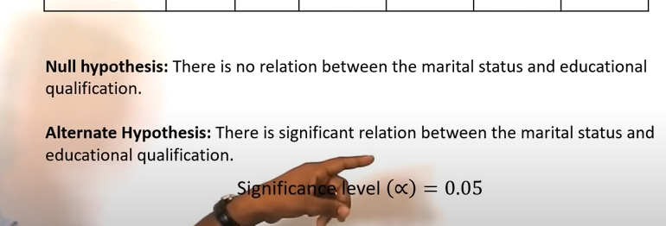

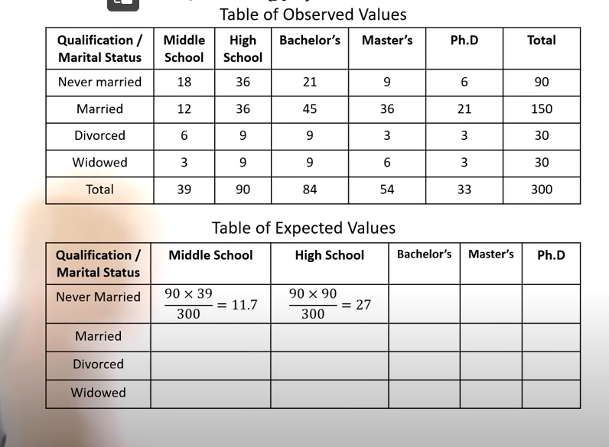

**Expected values= row total \*columntale/grand total**

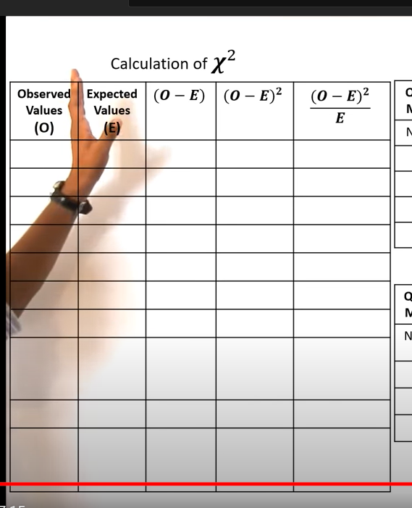

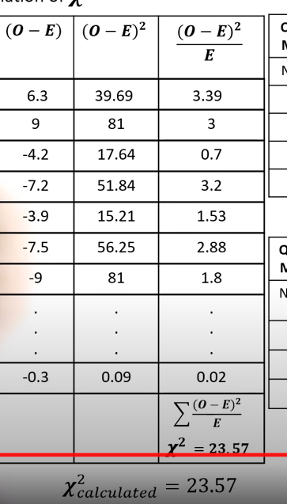

**This calculated chisquare compare with tabular value of chi square**

**For that we need degree of freedom**

